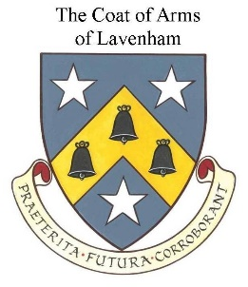

LAVENHAM PARISH COUNCIL

Environment Policy

As a Parish Council responsible for service delivery in the built and natural environments, we can, through the advice given to parishioners and those working with us, make a contribution towards the protection of our local environment.

Lavenham Parish Council aims to achieve the following:-

- Comply with all relevant local, national and international environmental
legislation that impinges upon our activities

- When no legislation exists, aspire to positively influence parishioners to
incorporate environmental considerations in all aspects of parish life

- Endeavour to positively influence suppliers, service providers and the
public towards environmental excellence

- Adopt environmental principles for purchasing consumables,
minimising waste, efficient use of energy and water and ensuring that
wastes are recycled whenever practicable and disposed of
appropriately

- Encourage adherence by all to guidance for the protection of conservation
areas that is documented at a national and local level and in the Lavenham Neighbourhood Plan

- To work with Babergh District Council’s Environmental Enforcement Team
for the environmental improvement of the parish.

Reviewed and Adopted: 8th May 2019
To be reviewed: May 2023

