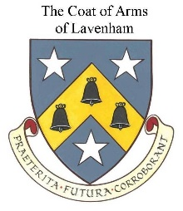 LAVENHAM PARISH COUNCIL

COMPLAINTS FORM

The Council is unable to accept anonymous complaints.

PLEASE PRINT ALL CONTACT DETAILS

Title: | First Name: | Surname:
Address
 |  |  | Postcode:

Daytime Phone Number
Evening Phone Number
E-Mail Address

1. Please describe the circumstances you are complaining about.

2. What do you consider the Council has done wrong or failed to do? Please give us as much detail as possible including times and dates where you have them.

3.Please describe the inconvenience or harm you feel that you have suffered as a result.

4. What do you think the Council can do to sort things out?

Signature and date:

Document control
Version and date | Adopted
Created June 2025 V1.0 | Adopted at Full Council meeting 3 July 2025

